**Visvesvaraya Technological University**

# Belagavi, Karnataka, 590 014.



## AICTE Activity Point Programme on

## “Doubling The Village Income”

(Non-Credit Activity of 2 Weeks (80-90 hours))

Submitted in partial fulfillment of the requirements for the award of

**Bachelor of Engineering**

**in**

**Computer Science and Engineering**

**Semester IV**

**Academic Year 2021-22**

***Department of Computer Science & Engineering***

K.L.E.SOCIETY’S

|  |  |  |
| --- | --- | --- |
| **wps2** | **K. L. E. INSTITUTE OF TECHNOLOGY,**  Opp. Airport, Gokul, Hubballi-580 030  Phone: 0836-2232681 Website: www.kleit.ac.in | **wps3** |

**TEAM MEMBERS INVOLVED :**

NAME USN

1. K .V. HAMSASHRIE 2KE20CS030
2. ANUSHA .V. A 2KE20CS011
3. KOMAL .S . DIXIT 2KE20CS036
4. MEGHA .P. B 2KE20CS045

**DOUBLING THE INCOME OF VILLAGE USING ORGANIC FARMING**

**1.1 INTRODUCTION**

Food quality and safety are two vital factors that have attained constant attention in common people. Growing environmental awareness and several food hazards (e.g. dioxins, bovine spongiform encephalopathy, and bacterial contamination) have substantially decreased the consumer’s trust towards food quality in the last decades. Intensive conventional farming can add contamination to the food chain. For these reasons, consumers are quested for safer and better foods that are produced through more ecologically and authentically by local systems. Organically grown food and food products are believed to meet these demands**.** The term ‘organic’ was first coined by Northbourne, in 1940, in his book entitled ‘Look to the Land’ Northbourne stated that ‘the farm itself should have biological completeness; it must be a living entity; it must be a unit which has within itself a balanced organic life’. Northbourne also defined organic farming as ‘an ecological production management system that promotes and enhances biodiversity, biological cycles and soil biological activity’. Although India was far behind in the adoption of organic farming due to several reasons, presently it has achieved rapid growth in organic agriculture and now becomes one of the largest organic producers in the world.

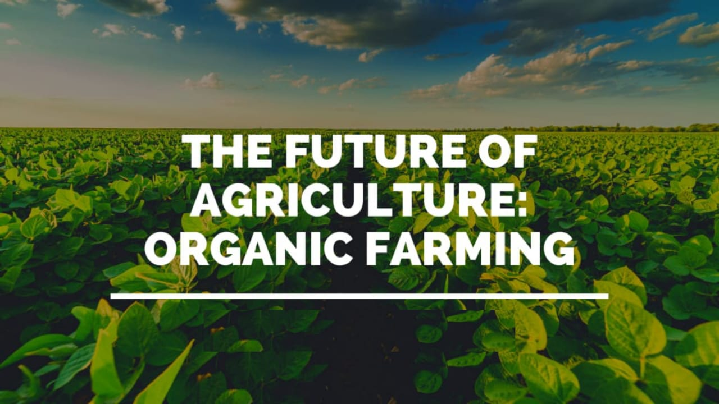

Fig 1.1 Introduction to organic farming

**1.2 LITERATURE SURVEY**

In recent years, organic farming as a cultivation process is gaining increasing popularity. Organically grown foods have become one of the best choices for both consumers and farmers. Organically grown foods are part of go green lifestyle. They mentioned that organic produce is not grown with synthetic pesticides, antibiotics, growth hormones, application of genetic modification techniques (such as genetically modified crops), sewage sludge, or chemical fertilizers. Whereas, conventional farming is the cultivation process where synthetic pesticide and chemical fertilizers are applied to gain higher crop yield and profit. In conventional farming, synthetic pesticides and chemicals are able to eliminate insects, weeds, and pests and growth factors such as synthetic hormones and fertilizers increase growth rate. As synthetically produced pesticides and chemical fertilizers are utilized in conventional farming, consumption of conventionally grown foods is discouraged, and for these reasons, the popularity of organic farming is increasing gradually.

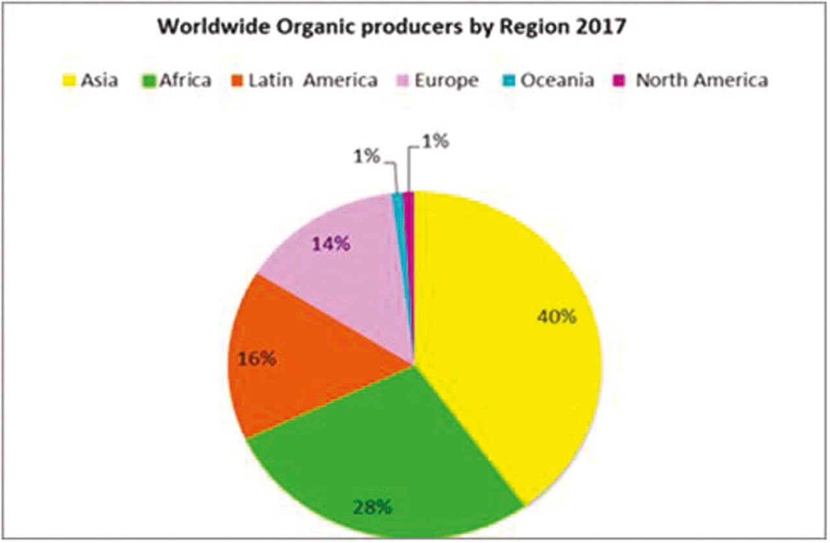

Fig 1.2 Survey

**1.3 PROCESS OF ORGANIC FARMING**

Organic farming and food processing practices are wide-ranging and necessitate the development of socially, ecologically, and economically sustainable food production system. The International Federation of Organic Agriculture Movements (IFOAM) has suggested the basic four principles of organic farming, i.e. the principle of health, ecology, fairness, and care. The main principles and practices of organic food production are to inspire and enhance biological cycles in the farming system, keep and enhance deep-rooted soil fertility, reduce all types of pollution, evade the application of pesticides and synthetic fertilizers, conserve genetic diversity in food, consider the vast socio-ecological impact of food production, and produce high-quality food in sufficient quantity. According to the National Organic Programme implemented by USDA Organic Food Production Act (OFPA, 1990), agriculture needs specific prerequisites for both crop cultivation and animal husbandry. To be acceptable as organic, crops should be cultivated in lands without any synthetic pesticides, chemical fertilizers, and herbicides for 3 years before harvesting with enough buffer zone to lower contamination from the adjacent farms. Genetically engineered products, sewage sludge, and ionizing radiation are strictly prohibited. Fertility and nutrient content of soil are managed primarily by farming practices, with crop rotation, and using cover crops that are boosted with animal and plant waste manures. Pests, diseases, and weeds are mainly controlled with the adaptation of physical and biological control systems without using herbicides and synthetic pesticides. Organic livestock should be reared devoid of scheduled application of growth hormones or antibiotics and they should be provided with enough access to the outdoor. Preventive health practices such as routine vaccination, vitamins and minerals supplementation are also needed.

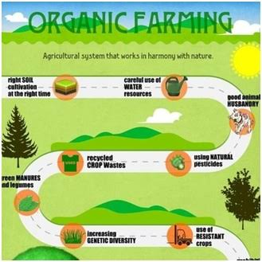

Fig 1.3 process of organic farming

**1.4 BENEFITS OF ORGANIC FARMING**

### **1.4.1 Nutritional benefits and health safety**

* The growing demand for organically farmed fresh products has created an interest in both consumer and producer regarding the nutritional value of organically and conventionally grown foods. According to a study conducted by AFSSA, organically grown foods, especially leafy vegetables and tubers, have higher dry matter as compared to conventionally grown foods. Woëse et al also found similar results. Although organic cereals and their products contain lesser protein than conventional cereals, they have higher quality proteins with better amino acid scores. Lysine content in organic wheat has been reported to be 25%–30% more than conventional wheat. Organically grazed cows and sheep contain less fat and more lean meat as compared to conventional counterparts.
* In a study conducted by Nürnberg et al, organically fed cow’s muscle contains fourfold more linolenic acid, which is a recommended cardio-protective ω-3 fatty acid, with accompanying decrease in oleic acid and linoleic acid. found that meat from an organically grazed cow contains high amounts of polyunsaturated fatty acids. The milk produced from the organic farm contains higher polyunsaturated fatty acids and vitamin A. Vitamin E and carotenoids are found in a nutritionally desirable amount in organic milk.
* Higher oleic acid has been found in organic virgin olive oil. Organic plants contain significantly more magnesium, iron, and phosphorous. They also contain more calcium, sodium, and potassium as major elements and manganese, iodine, chromium, molybdenum, selenium, boron, copper, vanadium, and zinc as trace elements.According to a review, which was based on the French Agency for food safety (AFSSA) report, organic products contain more dry matter, minerals, and antioxidants such as polyphenols and salicylic acid.
* Organic foods (94%–100%) contain no pesticide residues in comparison to conventionally grown foods.Fruits and vegetables contain a wide variety of phytochemicals such as polyphenols, resveratrol, and pro-vitamin C and carotenoids which are generally secondary metabolites of plants. In a study of Lairon, organic fruits and vegetables contain 27% more vitamin C than conventional fruits and vegetables.
* These secondary metabolites have substantial regulatory effects at cellular levels and hence found to be protective against certain diseases such as cancers, chronic inflammations, and other diseases. According to a [Food Marketing Institute (2008)](javascript:;), some organic foods such as corn, strawberries, and marionberries have greater than 30% of cancer-fighting antioxidants. The phenols and polyphenolic antioxidants are in higher level in organic fruits and vegetables. It has been estimated that organic plants contain double the amount of phenolic compounds than conventional ones. Organic wine has been reported to contain a higher level of resveratrol
* organically grown tomatoes contain more salicylic acid than conventional counterparts. Salicylic acid is a naturally occurring phytochemical having anti-inflammatory and anti-stress effects and prevents hardening of arteries and bowel cancer.
* As organically grown foods are cultivated without the use of pesticides and sewage sludge, they are less contaminated with pesticide residue and pathogenic organisms such as Listeria monocytogenes or Salmonella sp. or Escherichia coli.
* Therefore, organic foods ensure better nutritional benefits and health safety.

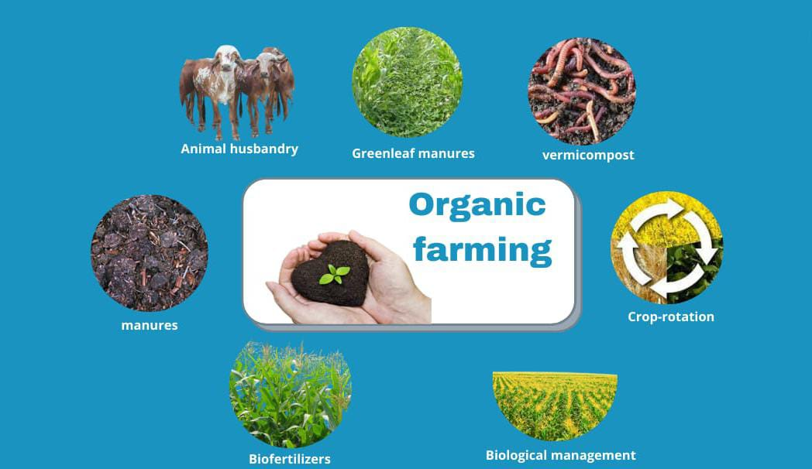

Fig 1.4 Benefits of organic farming

**1.4.2 Environmental impact**

Organic farming has a protective role in environmental conservation. The effect of organic and conventional agriculture on the environment has been extensively studied. It is believed that organic farming is less harmful to the environment as it does not allow synthetic pesticides, most of which are potentially harmful to water, soil, and local terrestrial and aquatic wildlife. In addition, organic farms are better than conventional farms at sustaining biodiversity, due to practices of crop rotation. Organic farming improves physio-biological properties of soil consisting of more organic matter, biomass, higher enzyme, better soil stability, enhanced water percolation, holding capacities, lesser water, and wind erosion compared to conventionally farming soil. Organic farming uses lesser energy and produces less waste per unit area or per unit yield. In addition, organically managed soils are of greater quality and water retention capacity, resulting in higher yield in organic farms even during the drought years.

**1.4.3 Socioeconomic impact**

Organic cultivation requires a higher level of labour, hence produces more income-generating jobs per farm. According to Winter and Davis (2006), an organic product typically costs 10%–40% more than the similar conventionally crops and it depends on multiple factors both in the input and the output arms. On the input side, factors that enhance the price of organic foods include the high cost of obtaining the organic certification, the high cost of manpower in the field, lack of subsidies on organics in India, unlike chemical inputs. But consumers are willing to pay a high price as there is increasing health awareness. Some organic products also have short supply against high demand with a resultant increase in cost. Biofertilizers and pesticides can be produced locally, so yearly inputs invested by the farmers are also low. As the labours working in organic farms are less likely to be exposed to agricultural chemicals, their occupational health is improved. Organic food has a longer shelf life than conventional foods due to lesser nitrates and greater antioxidants. Nitrates hasten food spoilage, whereas antioxidants help to enhance the shelf life of foods. Organic farming is now an expanding economic sector as a result of the profit incurred by organic produce and thereby leading to a growing inclination towards organic agriculture by the farmers.

**1.5 ORGANIC AGRICULTURE & SUSTAINANLE DEVELOPMENT**

The concept of sustainable agriculture integrates three main goals—environmental health, economic profitability, and social and economic equity. The concept of sustainability rests on the principle that we must meet the needs of the present without compromising the ability of future generations to meet their own needs. The very basic approach to organic farming for the sustainable environment includes the following:

1. Improvement and maintenance of the natural landscape and agro-ecosystem.
2. Avoidance of overexploitation and pollution of natural resources.
3. Minimization of the consumption of non-renewable energy resources.
4. Exploitation synergies that exist in a natural ecosystem.
5. Maintenance and improve soil health by stimulating activity or soil organic manures and avoid harming them with pesticides.
6. Optimum economic returns, with a safe, secure, and healthy working environment.
7. Acknowledgement of the virtues of indigenous know-how and traditional farming system.

Long-term economic viability can only be possible by organic farming and because of its premium price in the market, organic farming is more profitable. The increase in the cost of production by the use of pesticides and fertilizers in conventional farming and its negative impact on farmer’s health affect economic balance in a community and benefits only go to the manufacturer of these pesticides. Continuous degradation of soil fertility by chemical fertilizers leads to production loss and hence increases the cost of production which makes the farming economically unsustainable. Implementation of a strategy encompassing food security, generation of rural employment, poverty alleviation, conservation of the natural resource, adoption of an export-oriented production system, sound infrastructure, active participation of government, and private-public sector will be helpful to make revamp economic sustainability in agriculture.

**1.5.1 Social Sustainability**

It is defined as a process or framework that promotes the wellbeing of members of an organization while supporting the ability of future generations to maintain a healthy community. Social sustainability can be improved by enabling rural poor to get benefit from agricultural development, giving respect to indigenous knowledge and practices along with modern technologies, promoting gender equality in labour, full participation of vibrant rural communities to enhance their confidence and mental health, and thus decreasing suicidal rates among the farmers. Organic farming appears to generate 30% more employment in rural areas and labour achieves higher returns per unit of labour input.

**1.6 CONSTRAINTS OF ORGANIC FARMING**

1. Lack of awareness
2. Lack of good marketing policies
3. Shortage of biomass
4. Inadequate farming infrastructure
5. High input course of farming
6. Inappropriate marketing of organic input
7. Inefficient agricultural policies
8. Lack of financial support
9. Imability to meet the export demand.

**1.7 APPROACH FOR THE INCOME**

As we know that doubling of the village income is necessary, we can take organic farming as one of the domain to increase the income.

**ORGANIC FARMING**

Recently, the Government of India has implemented a number of programs and schemes for boosting organic farming in the country. Among these the most important include

(1) The Paramparagat Krishi Vikas Yojana,

(2) Organic Value Chain Development in North Eastern Region Scheme,

(3) Rashtriya Krishi Vikas Yojana,

(4) The mission for Integrated Development of Horticulture (a. National Horticulture Mission, b. Horticulture Mission for North East and Himalayan states, c. National Bamboo Mission, d. National Horticulture Board, e. Coconut Development Board, d. Central Institute for Horticulture, Nagaland),

(5) National Programme for Organic Production,

(6) National Project on Organic Farming,

(7) National Mission for Sustainable Agriculture.

Zero Budget Natural Farming (ZBNF) is a method of farming where the cost of growing and harvesting plants is zero as it reduces costs through eliminating external inputs and using local resources to rejuvenate soils and restore ecosystem health through diverse, multi-layered cropping systems. It requires only 10% of water and 10% electricity less than chemical and organic farming. The micro-organisms of Cow dung (300–500 crores of beneficial micro-organisms per one gram cow dung) decompose the dried biomass on the soil and convert it into ready-to-use nutrients for plants. Paramparagat Krishi Vikas Yojana since 2015–16 and Rashtriya Krishi Vikas Yojana are the schemes taken by the Government of India under the ZBNF policy. According to kumar, in the union budget 2020–21, Rs 687.5 crore has been allocated for the organic and natural arming sector which was Rs 461.36 crore in the previous year. The popularity of organic foods is due to its nutritional and health benefits and positive impact on environmental and socioeconomic status and by a survey conducted by the UN Environment Programme, organic farming methods give small yields (on average 20% lower) as compared to conventional farming. As the yields of organically grown foods are low, the costs of them are higher. The higher prices made a barrier for many consumers to buy organic foods. Organic farming needs far more lands to generate the same amount of organic food produce as conventional farming does, as chemical fertilizers are not used here, which conventionally produces higher yield. Organic agriculture hardly contributes to addressing the issue of global climate change. During the last decades, the consumption of organic foods has been increasing gradually, particularly in western countries. Inhana Rational Farming Technology developed on the principle ‘Element Energy Activation’ is a comprehensive organic method for ensuring ecologically and economically sustainable crop production and it is based on ancient Indian philosophy and modern scientific knowledge.

The technology works towards (1) energization of soil system: reactivation of soil-plant-microflora dynamics by restoration of the population and efficiency of the native soil microflora and (2) energization of plant system: restoration of the two defence mechanisms of the plant kingdom that are nutrient use efficiency and superior plant immunity against pest/disease infection.

1.8 IDENTIFICATION OF ORGANIC FARMING

This product of ENVISION will deliver a fully automated organic crop identification. It will identify whether a particular crop type declared as organic is classified as such based on a traffic light system. Plants cultivated under organic and conventional farming practices present biological, chemical and physical differences. The differences can be detected by satellite imagery, especially during the vegetative and reproductive growth stages. The logic behind the service is to identify distinct patterns characterising the growth and evolution of organic and conventional crops during the growing season through high-resolution optical and radar satellite images depicting the phenological status of the cultivated parcels.

The tool will enable the continuous, all-year-round and territory-wide monitoring of organic farming and crops in general, including verifying actual cropped area, the presence of crops, the crop’s performance, and the crop’s anticipated yield. The product will build a traffic light system with the cultivation method classification at the parcel level. The tool will identify the cultivation practices by the end of the growing season, and the traffic light system will enable a smart sampling technique for the inspections. Each parcel will be characterised by its classification decision's confidence (red, green, blue).

The identification of the organic farming practices tool to be produced by ENVISION aims at compliance checks. They provide alerts at various time points in the growing season and support Certification Bodies (CBs) in pursuing smart sampling.

Evaluation can re-use the data provided by the tool to cross-validate the data recorded by CBs and surveys, e.g., the FSS, concerning the agricultural area under organic farming. This is context indicator C.33 and a primary Farm-to-Fork policy target. Also, since the tool provides the information annually and timely, it will be a good source of updated data for ongoing or intermediate evaluations. Since the tool can provide estimates of anticipated yields, it may contribute to the estimation of the new PMEF impact indicator I.29 ‘Responding to consumer demand for quality food: Value of production under EU quality schemes and organics’. The statistical authority of the Member State may derive the average producer and consumer prices for organic products needed for an approximation of the value of organic production.

In addition, data from the tool in association with data from CBs and data from IACS can support the evaluation of the effects of CAP on the adoption of organic farming by facilitating the construction of beneficiaries and non-beneficiaries samples of farms.

The tool's adoption requires access to EO, the adaptation and application of the algorithms recognising the characteristics of organic practices and their training on specific crop types of the region or the Member State. It is assumed that the IT infrastructure is adequate and that the evaluator has the skills to use the data. In general, when using EO, several conditions may limit their utility and functionality. For this tool, the most critical limitation is the extent of inconclusive parcels, i.e. parcels with a blue traffic light. Inconclusive parcels may be due to specific EO factors such as cloudiness or the prevalence of small parcels and also may be due to difficulties in producing the algorithms to train and forecast organic practices.

1.9 STEPS TO SUCCESSFUL ORGANIC TRANSITION

The transition from conventional to organic farming requires numerous changes. One of the biggest changes is in the mindset of the farmer. Conventional approaches often involve the use of quick-fix remedies that, unfortunately, rarely address the cause of the problem. Transitioning farmers generally spend too much time worrying about replacing synthetic input with allowable organic product instead of considering management practices based on preventative strategies. Here are a few steps new entrants should follow when making the transition to organic farming:

**A) Understand the basics of organic agriculture and the organic farming standards**

Since organic production systems are knowledge based, new entrants and transitional producers must become familiar with sound and sustainable agricultural practices. Transitional producers should be prepared to read appropriate information, conduct their own trials and participate in formal and informal training events. As mentioned, switching from conventional to organic farming is more than substituting synthetic materials to organic allowed materials. Organic farming is a holistic system that relies on sound practices focused on preventative strategies. Since there are often few organic remedies available to organic producers for certain problems, prevention is the key element in organic production.

**B) Identify resources that will help you**

Existing organic farmers are generally very helpful in sharing valuable technical information. A good mentor should be able to provide transitional producers with knowledge, practical experience and suggest appropriate reading materials. Mentors are able to identify some of the most important challenges transitional farmers will be confronted with. Mentors may also help source production materials that are otherwise difficult to find. Producers should also contact agrologists, veterinarians and other agricultural and financial consultants, in order to learn ways to improve their current farming practices.

The Internet is a valuable source of information, especially to new organic farmers. A broad range of reading materials are available from many organic/ecological organizations such as the Organic Agriculture Centre of Canada (OACC), the Atlantic Canadian Organic Regional Network (ACORN), the Canadian Organic Growers (COG), the Certified Organic Associations of British Columbia (COABC), the National Sustainable Agriculture Information Services/Appropriate Technology Transfer for Rural Areas (ATTRA), the Sustainable Agriculture Research and Education (SARE), and the Agri-réseau/agriculture biologique- Quebec. Consider joining an organic organization or network to access these valuable resources and establish good working contacts.

**C) Plan your transition carefully**

Develop a transitional plan with clear and realistic goals. The plan should clearly identify various steps to be taken in making the transition to organic and be sure to include realistic timeframes. Identify your strengths and weaknesses. Consider ways to address any weaknesses, while building on strengths. The business side of the transitional plan should contain a multiple year budget and an effective/realistic marketing strategy. Make sure your list of expenses is comprehensive. Include all prerequisites to begin the transition; such as, mechanical weeding equipment, specialized composting equipment and applicators, additional handling equipment dedicated to the organic products, and processing equipment. Although the demand for organic products is continually growing, growers need to make sure they have a reliable market for the organic products they plan to produce.

Careful planning is very important. During the early part of the transitional period, yields are often depressed and premium prices for certified organic products are generally not yet obtainable. Use realistic yields and prices when evaluating the feasibility of your project.

**D) Understand your soils and ways to improve them**

Since soil is the heart of the organic farming system, it is crucial that new entrants understand the various characteristics and limitations of the soils found on their farm. Soil suitability may vary significantly from one field to the next. Fields with good drainage, good level of fertility and organic matter, adequate pH, biological health, high legume content, and with less weed and pest pressure, are excellent assets. Often these fields are the first ones ready for transition and certification.

Many tools exist to assess soils. Soil chemical, physical and biological analyses, soil survey and legume composition field assessments, and field yield histories are very important and should be considered early in the transition. Unhealthy soils require particular attention.

1. **CONCLUSION**

* Organic farming yields more nutritious and safe food. The popularity of organic food is growing dramatically as consumer seeks the organic foods that are thought to be healthier and safer. Thus, organic food perhaps ensures food safety from farm to plate. The organic farming process is more eco-friendly than conventional farming. Organic farming keeps soil healthy and maintains environment integrity thereby, promoting the health of consumers. Moreover, the organic produce market is now the fastest growing market all over the world including India. Organic agriculture promotes the health of consumers of a nation, the ecological health of a nation, and the economic growth of a nation by income generation holistically. India, at present, is the world’s largest organic producers and with this vision, we can conclude that encouraging organic farming in India can build a nutritionally, ecologically, and economically healthy nation in near future.
* Future PerspectivesOrganic farmers depend greatly on versatile understanding of soil science and ecol-ogy. Modern organic farming methods are used to guarantee fertility and pest/weed control with conventional techniques of crop rotation. Organic farming has to be implicated as a feasible option compared to conventional approaches in agriculture. Thousands of farmers have transformed to this method as a result of a higher de-mand for organically developed foodstuff. Organic farming also involves access to food by dropping threats of disease, raising productivity and biodiversity over the lasting period, and giving means for limited manufacture and access to food. Other advantages of organic agriculture beyond the purely financial ones include con-servation of natural resources, health protection, risk reduction, increased flexibil-ity to adverse weather, and farmer authority through the attainment of knowledge
* 27910 Organic Farming: The Return to Natureand higher dependence on limited inputs. Sustainable earnings in organic farming would not only include safe food production but also shielding of natural environ-ment and maintenance of limited assets. Today, the organic agriculture sector is one of the fastest growing food segments, thrust to which is provided by many factors like introduction of policies that prove to be encouraging for organic agriculture, taking away of government funding on agricultural inputs, controversial debate on genetic modification related to food safety and crisis aggravated by foot and mouth and mad cow diseases and dioxin-contaminated food. On the demand side, forceful marketing and promotion strategies of supermarkets and retailers have produced new marketing prospects in northern countries. Food retailing chains have played a significant role in promoting the market growth for organic food product.

REFERENCES:.

Organic food business in India: a survey of companies.

*Research in Economics and Management* doi:[10.22158/rem.v3n2P72](https://doi.org/10.22158/rem.v3n2P72).

[Google Scholar](https://scholar.google.com/scholar_lookup?title=Organic%20food%20business%20in%20India%3A%20a%20survey%20of%20companies&author=A.%20Mukherjee&author=A.%20Kapoor&author=S%20Dutta&publication_year=2018&journal=Research%20in%20Economics%20and%20Management&volume=3&pages=72) [Crossref](http://dx.doi.org/10.22158/rem.v3n2P72) [WorldCat](https://www.worldcat.org/search?q=ti:Organic%20food%20business%20in%20India%3A%20a%20survey%20of%20companies&qt=advanced&dblist=638)

High-tech strategies for small farmers and organic farming

. <http://news.bio-based.eu/high-tech-strategies-for-small-farmers-and-organic-farming/>.

Nutritional quality and safety of organic food. A review

[Google Scholar](https://scholar.google.com/scholar_lookup?title=Nutritional%20quality%20and%20safety%20of%20organic%20food.%20A%20review&author=D.%20Lairon&publication_year=2010&journal=Agronomy%20for%20Sustainable%20Development&volume=30&pages=33-41)